AWS EC2 Linux Instance: Step by step procedure to create Linux instance in AWS EC2 and one tier static deploy Web application in it.

**Step1:** Create one free tier aws account and login as root user.

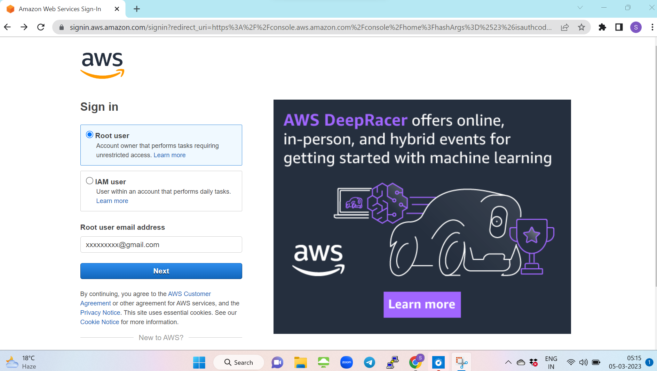

**Step 2:** go to AWS all services and search for compute and select EC2, which elastic compute cloud.

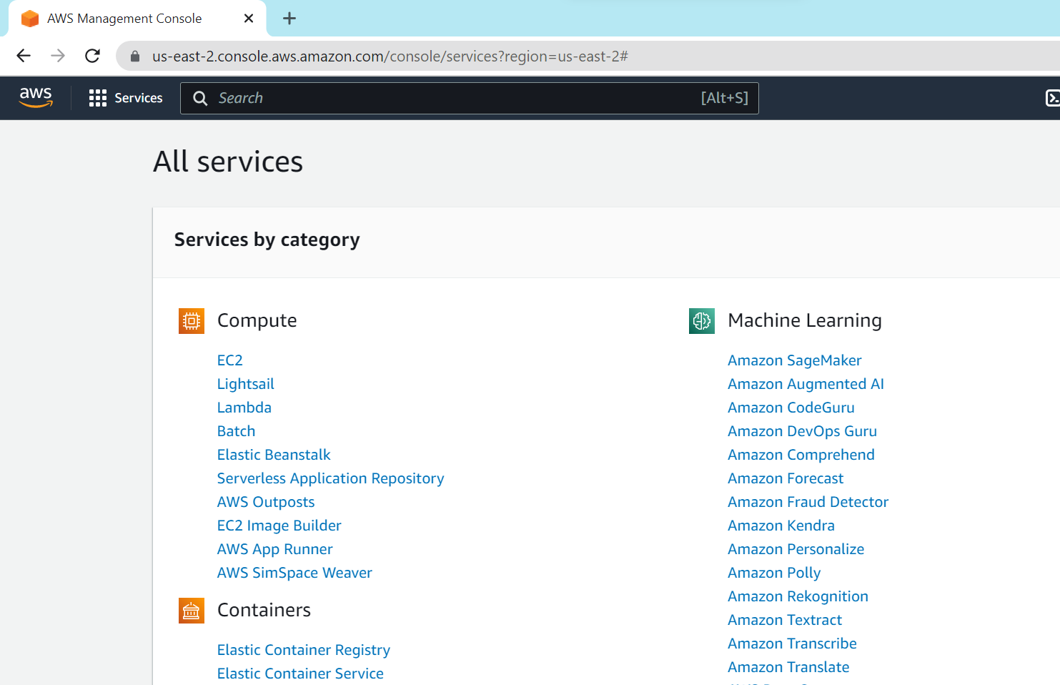

**Step 3:**

Go to instances.

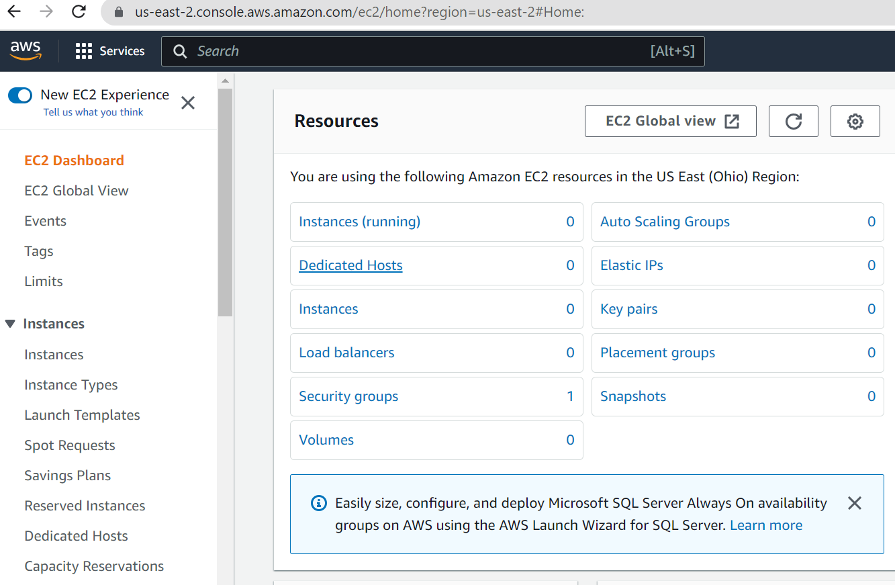

**Step 4:** Give name to your Instance in Name and tags.

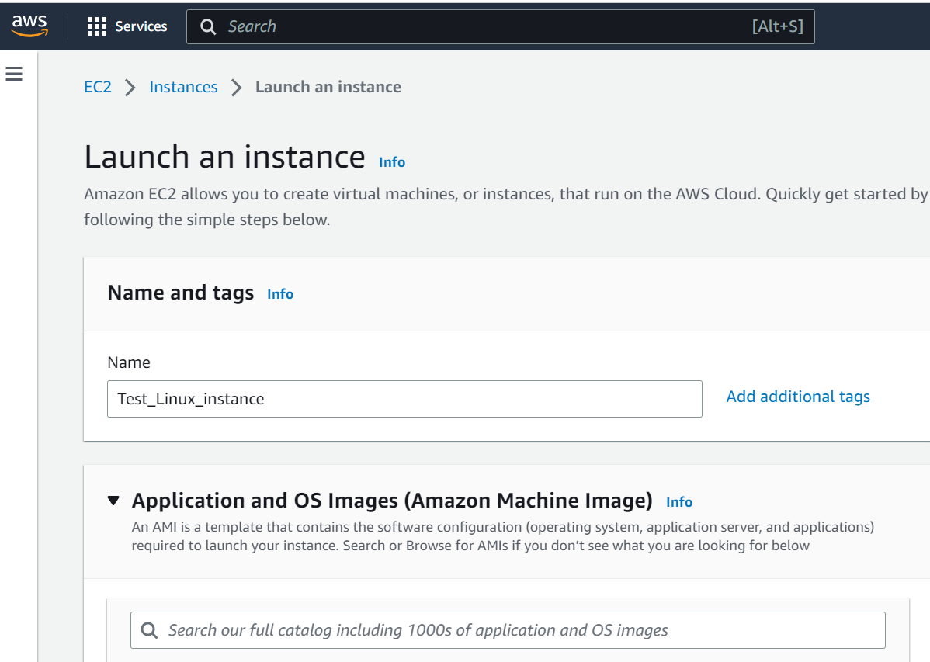

**Step 5:** Choose free tier AMI, i.e one need to choose the OS for their server. (linux/Windows/any other linux flavours) .I have choosed Amazon linux.

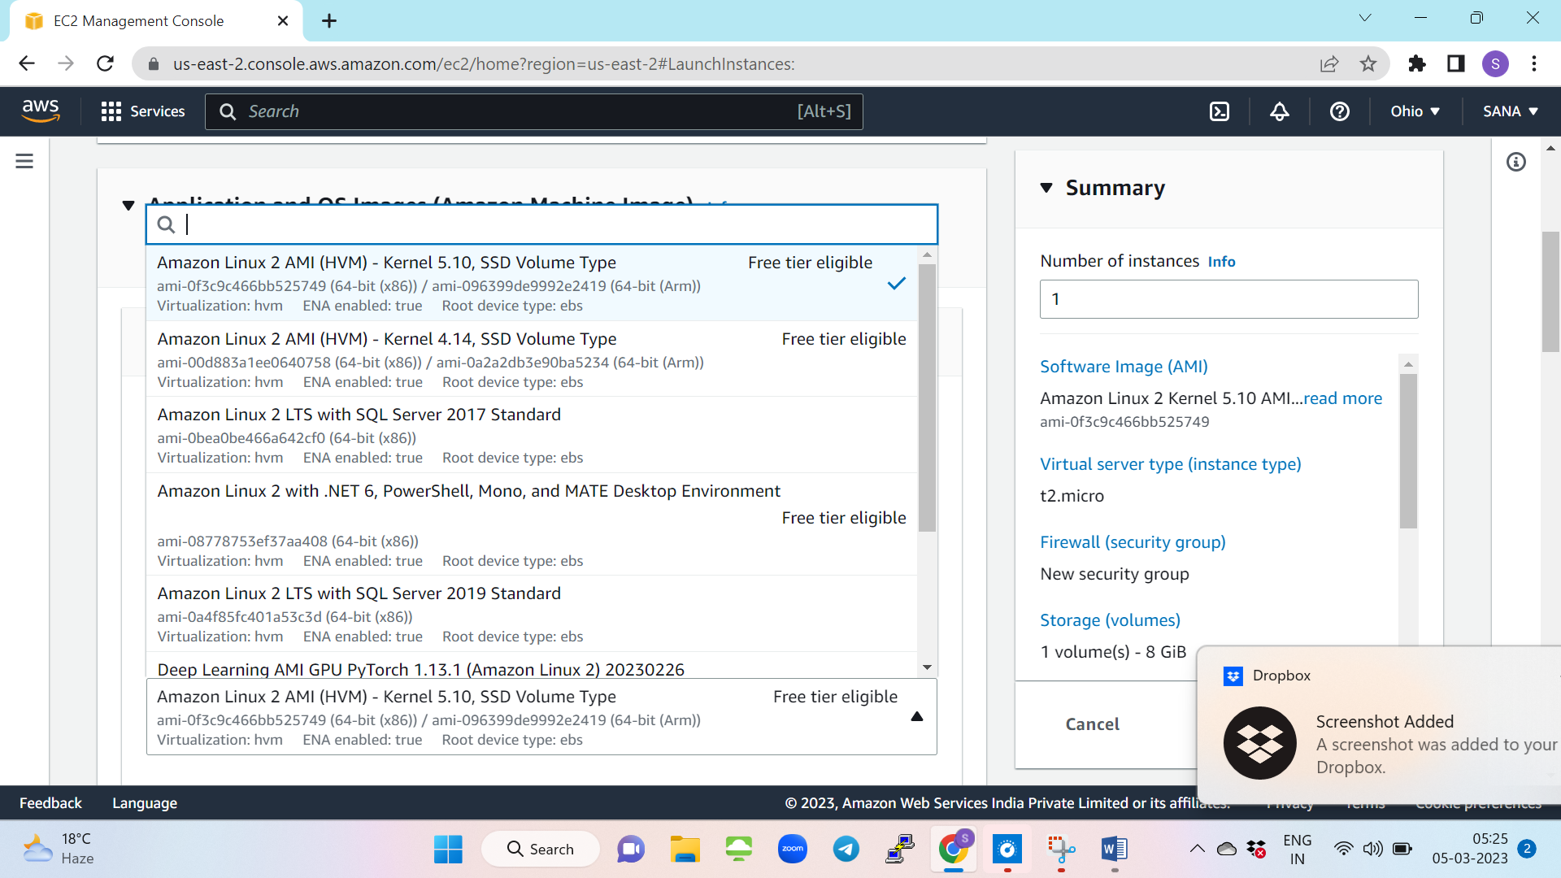

**Step 6:** Give Keypair name , download PPK putty private key file for your linux instance.

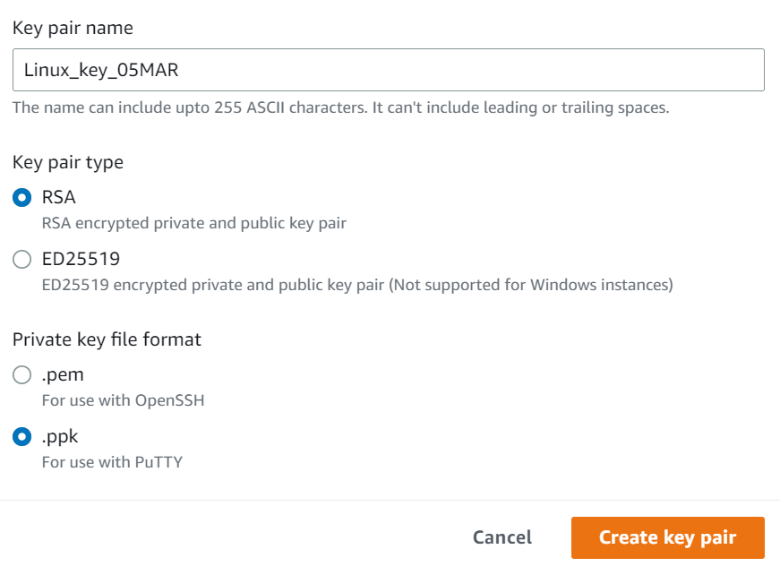

**Step 7:** For linux instance, in network settings,

A protocol is a set of standard rules which must be followed by two systems (client&server) in order to make communication possible,default protocol for linux is ssh. i.e: SSH, also known as Secure Socket Shell, is a network protocol that provides administrators with a secure way to access a remote computer.

In this document, we are going to launch simple webserver over EC2,for that Http protocol is required.( **HTTP** is a protocol for fetching resources such as HTML documents.)

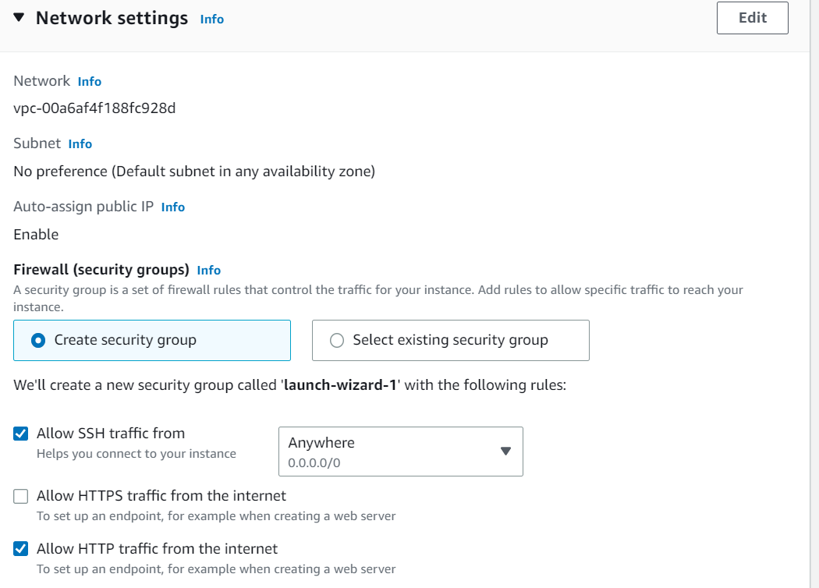

**Step 8:** give default storage provided by AWS for free tier.preview the summary and launch as shown below.

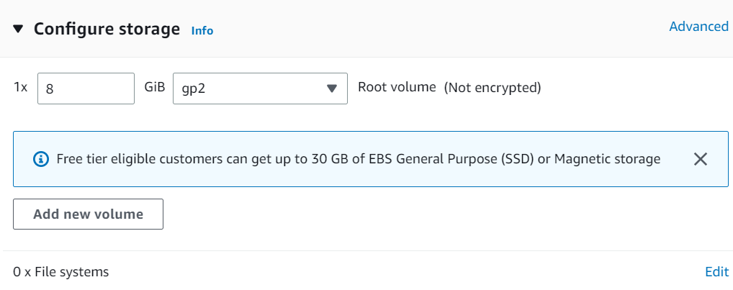

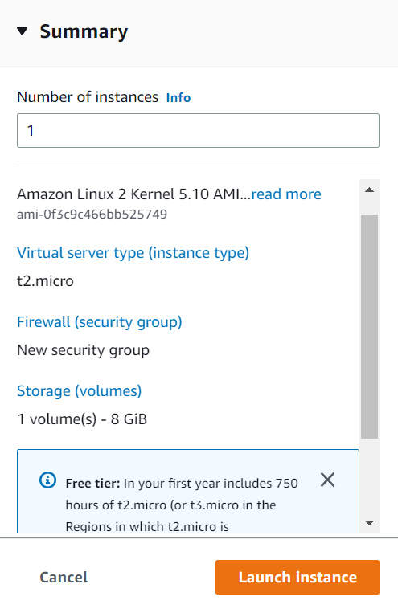

**Step 9:** Instance successfully launched in your required region.Make sure you are searching in the region where you created your actual instance.

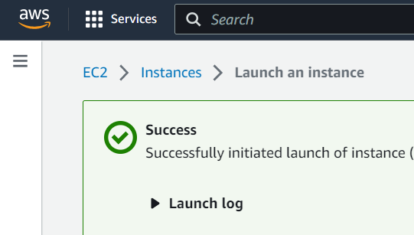

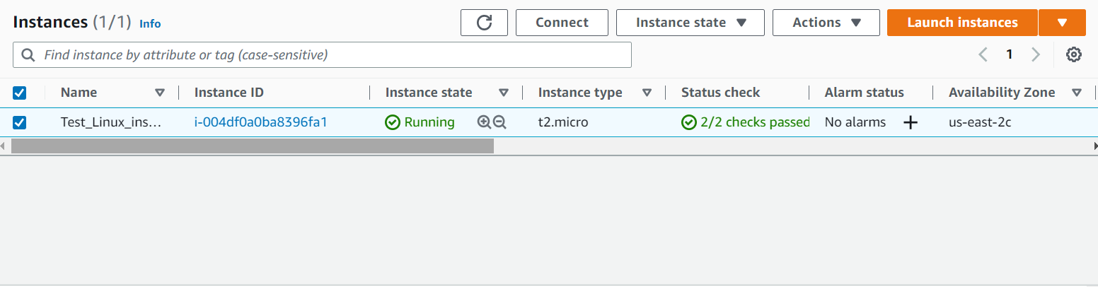

**Step 10:** Ensure 2/2 checks for your EC2 instance is passed.

When an EC2 instance is launched, AWS checks whether that ec2 is able to connect to the network or not. It does so in two steps.

**Step 10a:** **System check,** this checks for proper hardware configuration of the instance at host level. It should be noted that you can not check these. These are aws managed. The best you can do is just stop and start the Instance in case system checks fail. It simply deallocates the previous VM and a new VM on different hardware is provisioned. If you want to retain public IP and other related stuff, you can configure Auto Recovery of instance from cloudwatch console.

**Step 10b :** **Instance check,** this check is done to check software(os) level configuration of the instance. This can be looked into by you. If this check fails then you will need to check either user data/ launch configuration or AMI/OS configuration.

**Step 11:**Copy Public Ip under networking. Paste it in Putty as shown below.

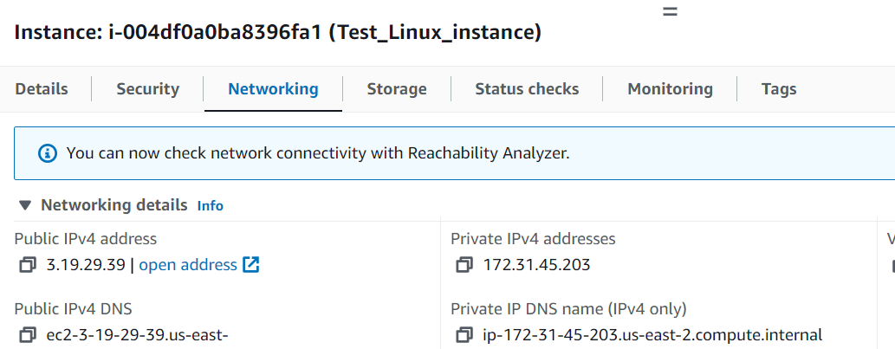

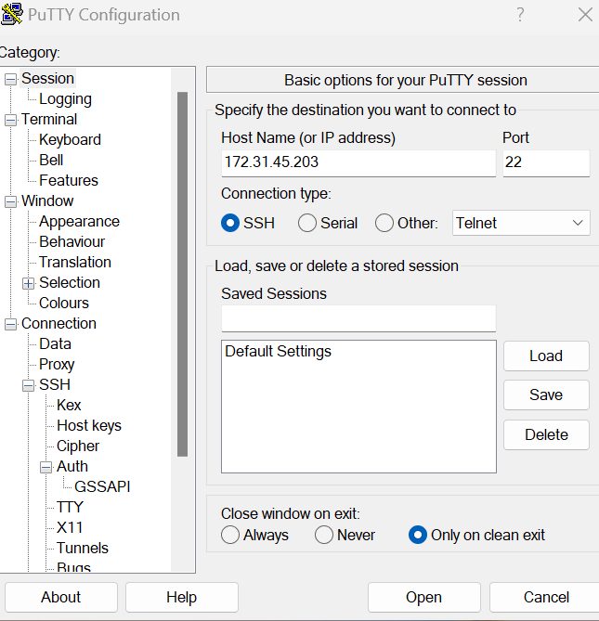

Go to SSH then choose Auth in that and browse and give your PPK file.

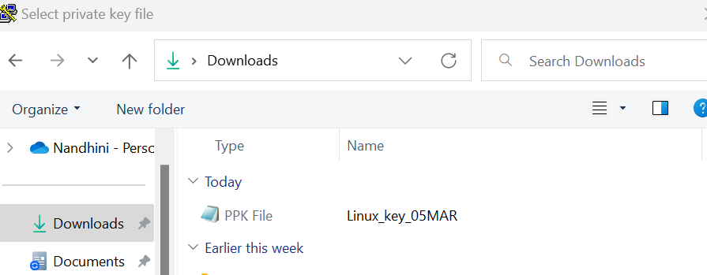

Under connection ,give the timings ,how long one need to keep your session alive. One can customise the screen settings in putty.

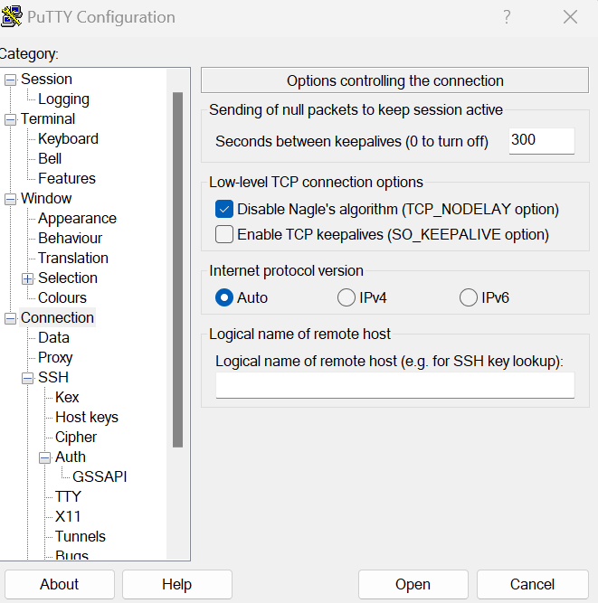

Give open and you will get the below window.accept and open it.

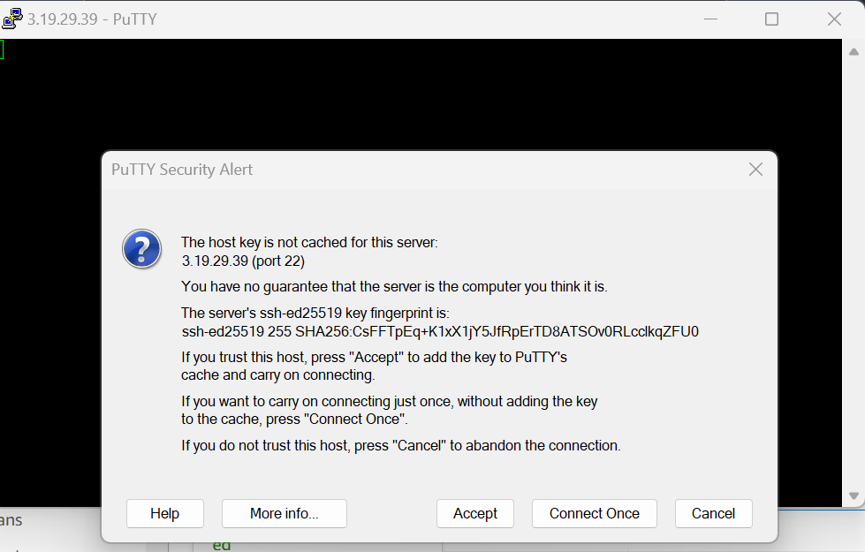

Now Linux machine Virtualisation has been done with the help of Putty ssh client. In linux machine one need to be root user to install any thing.

Give sudo –i and switch to root user.give yum install httpd –y to install apache web server,in the below Screenshot,I have provide without –y for your refrence.

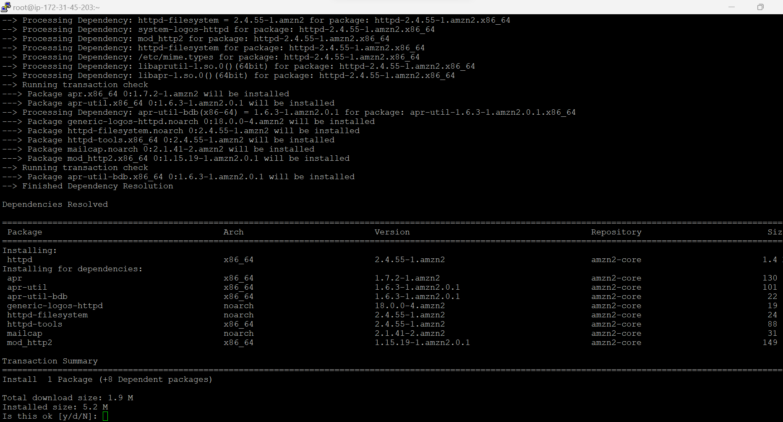

Give y to install further. Once done you will get the below page.

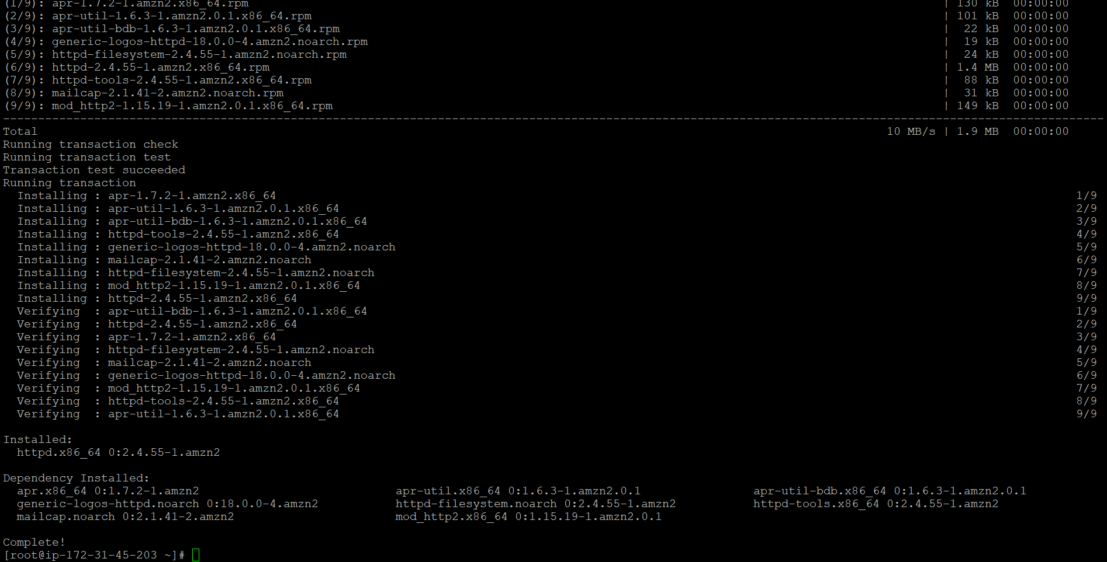

One can check whether httpd is installed or not using below commands.httpd –V or yum info httpd

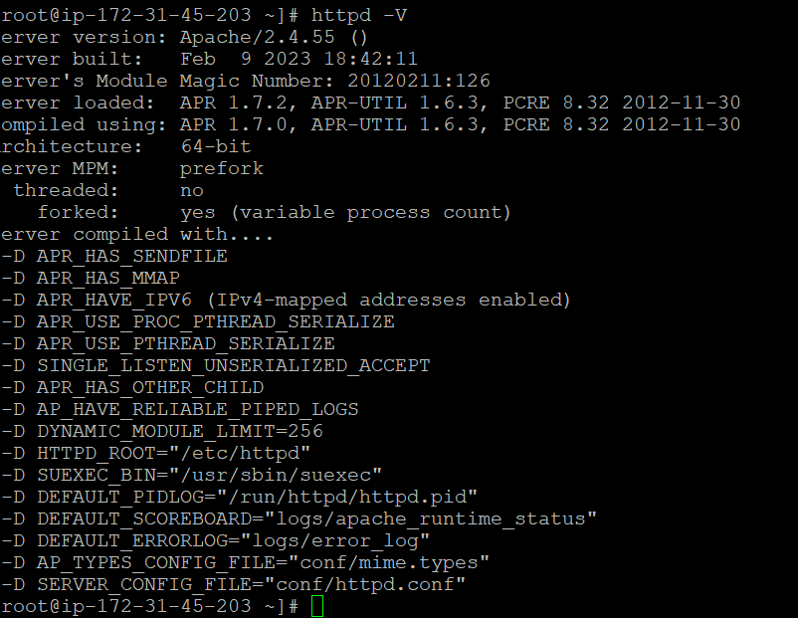

Or

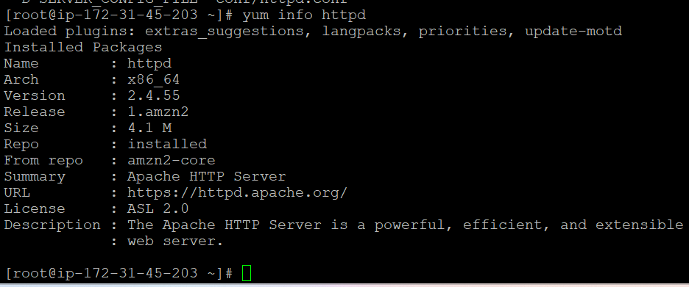

**Step 12:** Start the installed httpd service using ‘systemctl start httpd’. After starting check the status to ensure it by using command “service status httpd”

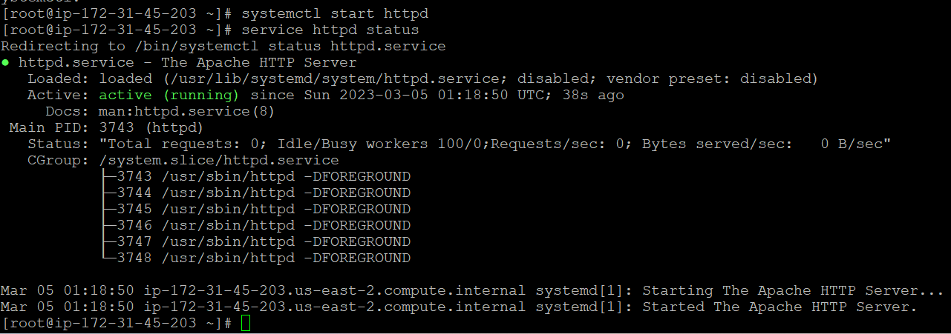

Now copy and past the Public ip of your Ec2 Linux instance and paste it in browser. Apache webserver is launched successfully.

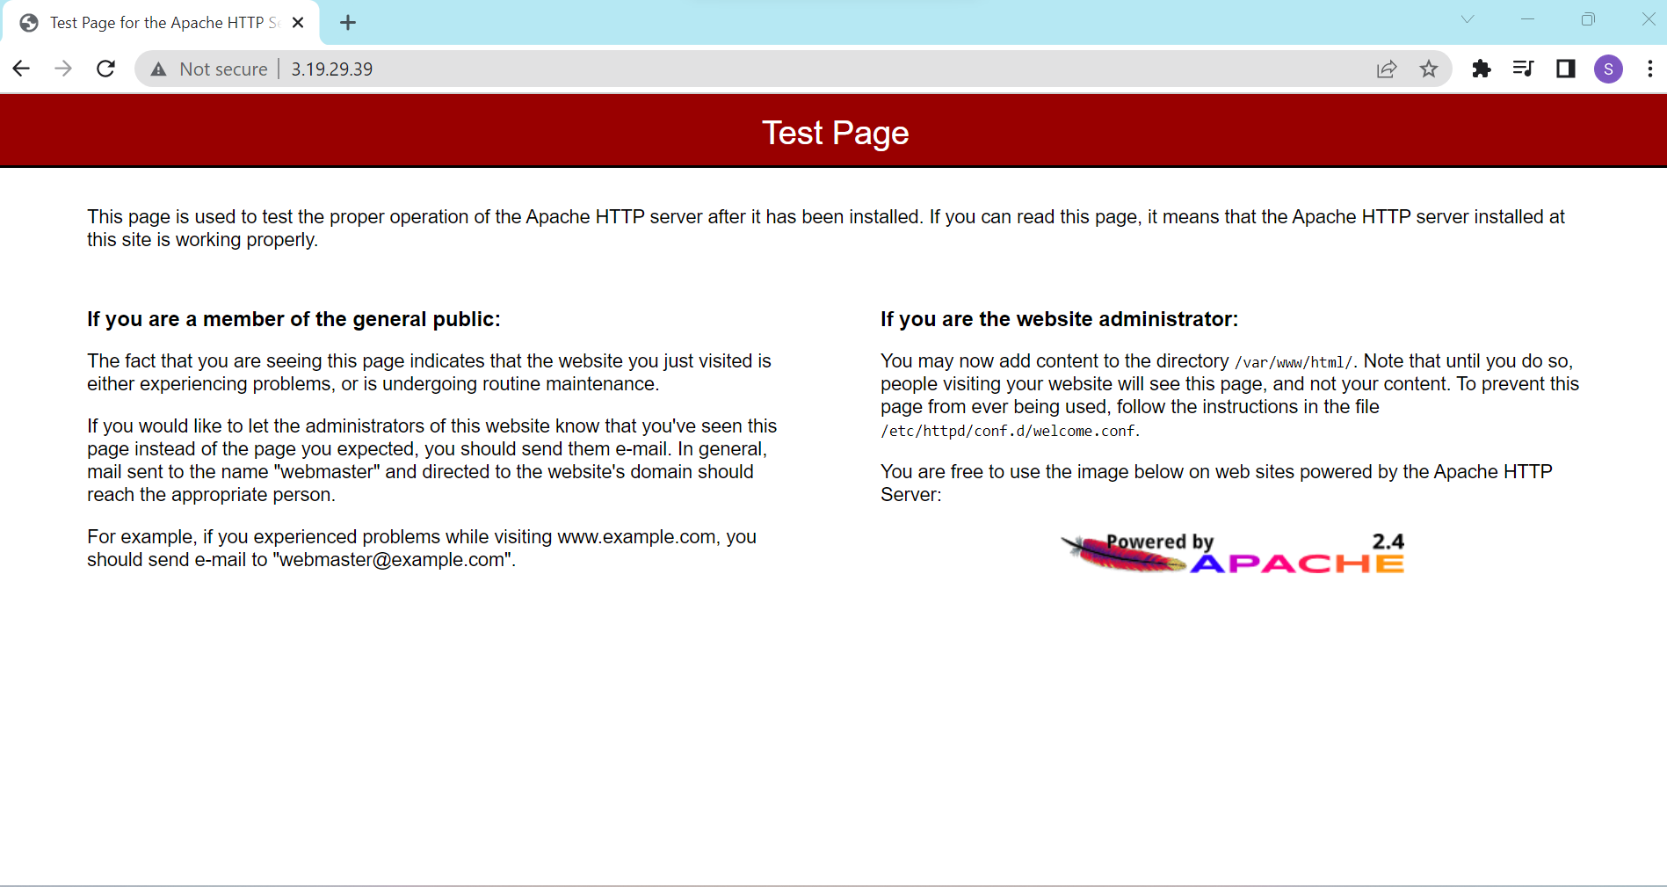

We have successfully launched default webserver for linux instance.Next,In realtime over this real application/developer written app will be launched. Here I’m going to show simple freeware application to launch/deploy over EC2 Linux server.

Step 14: To have opensource application to deploy over your server/EC2 instance ,go to this site <https://freewebsitetemplates.com/> and download any Application.

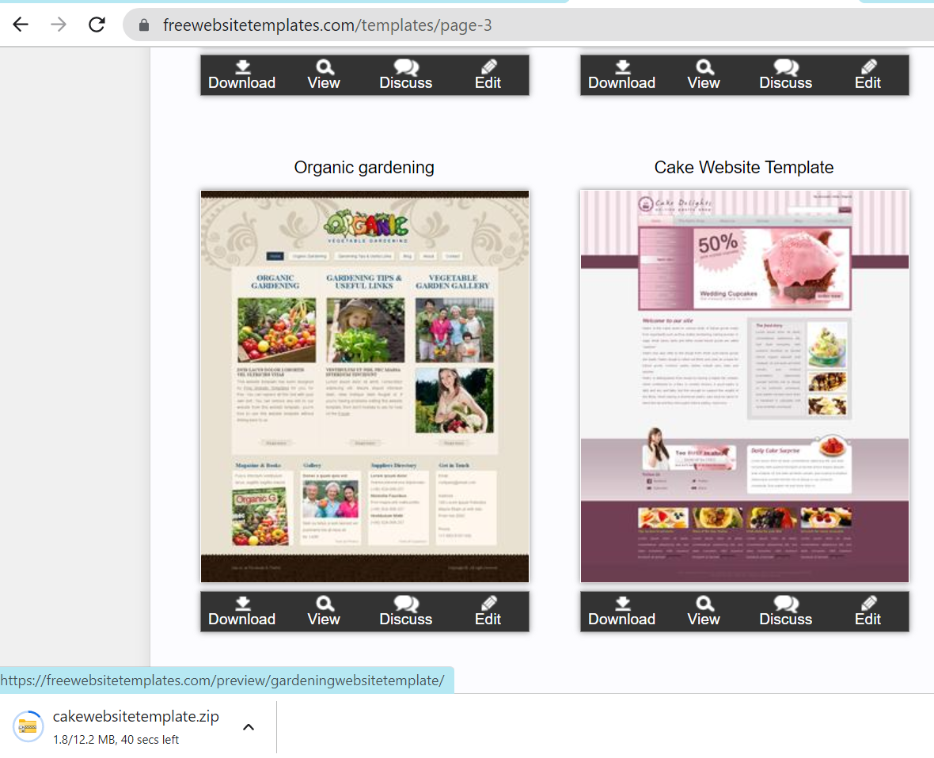

One need to extract and can Copy the downloaded application to Linux server using Winscp ssh client. Give public ip as winscp’s username and select advanced option and go to ssh option on your left most corner and chose auth and provide your ppk file. And give yes to further proceed.

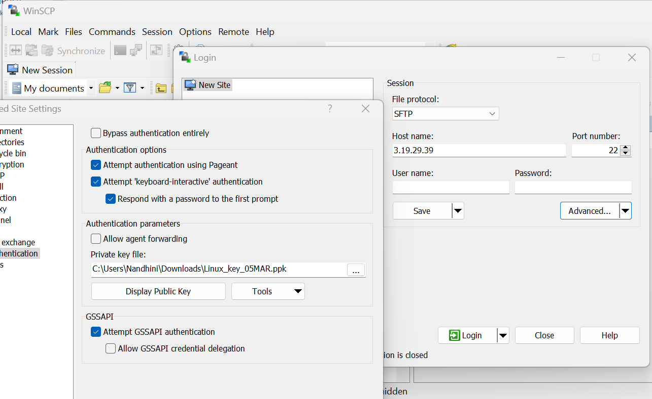

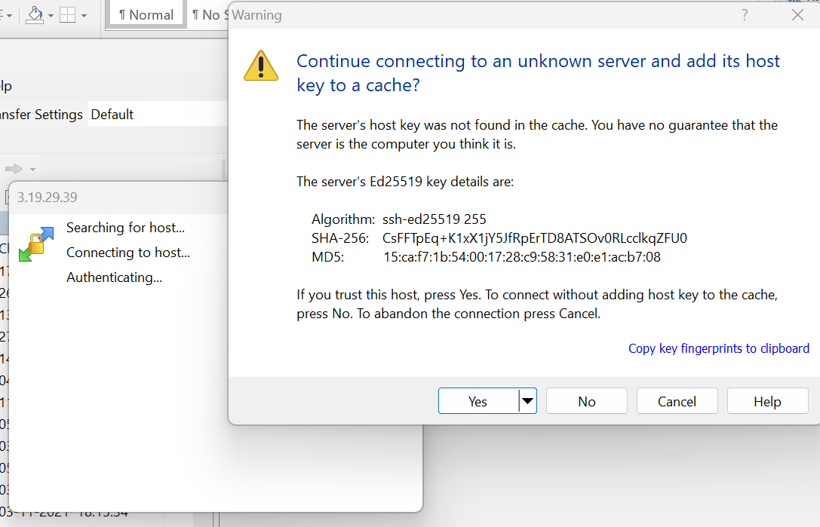

One may face this error ,

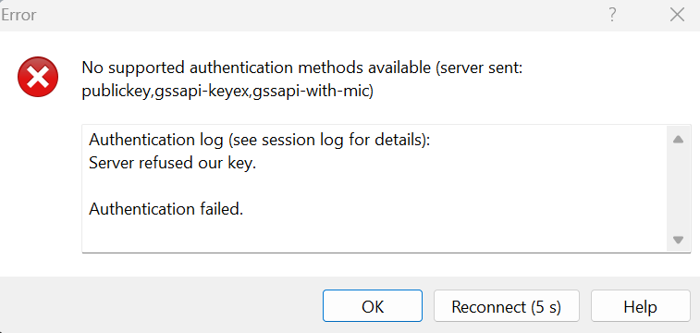

One need to place that downloaded application files in the path where apache is launched. i.e /var/www/html ,so using winscp,one need to copy those downloaded free app in this path /var/www/html.for that /var/www/html give full permission to allow copy from external machine.i.e from your laptop/machine where you downloaded your application.

(Note:Apache installed path is shown in your launched page from there one can refer the installed path)

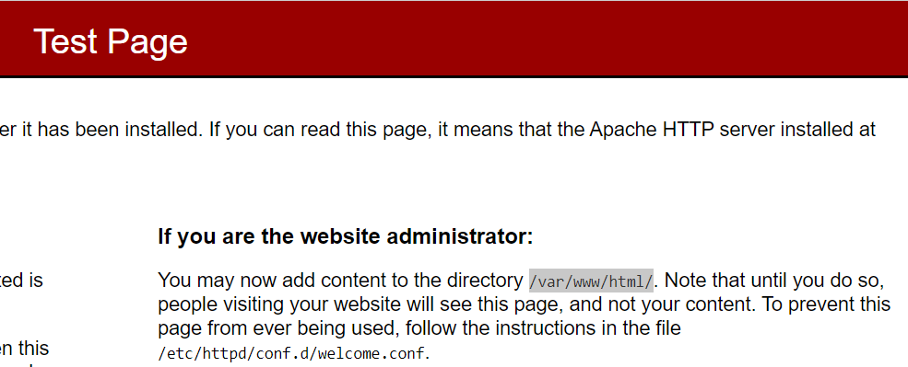

Before launching your application no files present in that path.

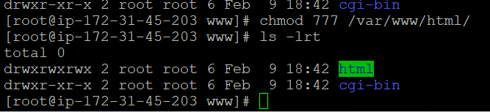

Now after giving full permission,one can scp the downloaded application file from local machine to remote. By default you will be dropped in home path of ec2 machine.i.e /home/ec2-user

Step 15: Navigate to /var/www/html/ and drag and drop your application . Now one can see the application deployed in the path /var/www/html.

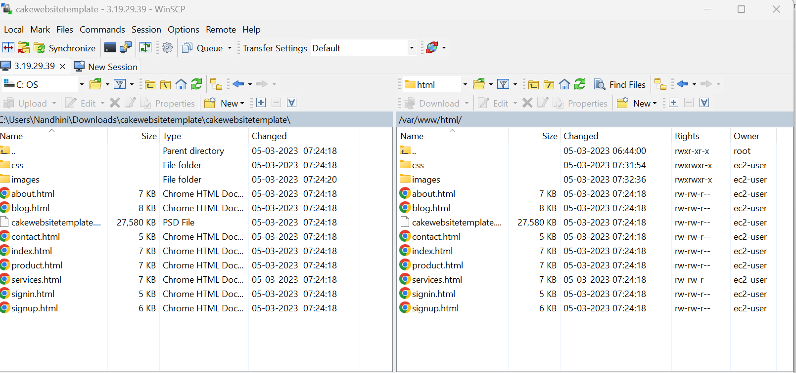

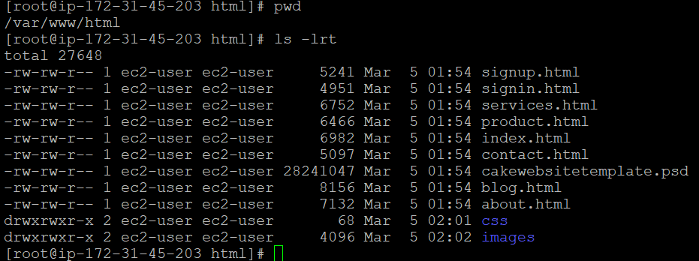

Step 16: Now go back to browser and refresh the page. One tier static web Application is deployed successfully

